Circular Dissection

Definition
# Source: AI Source: Provided by: [Data Path: Persons Table -> ID Column: 1, Name_En Column: Motasem Essam] -> From: [ChatGPT] on [7/25/2026]
Circular Dissection is a geometric dissection method in which a circular figure, or a figure containing curved boundaries, is divided into smaller regions using radii, diameters, chords, arcs, or other curves and line segments.
The resulting pieces may include sectors, semicircles, circular segments, annular regions, and mixed curved-polygonal regions. These pieces can be measured, compared, rearranged, or combined to study geometric properties and area relationships.

Simple Definition
# Source: AI Source: Provided by: [Data Path: Persons Table -> ID Column: 1, Name_En Column: Motasem Essam] -> From: [ChatGPT] on [7/25/2026]
Circular dissection means dividing a circle or circular region into smaller pieces using straight lines and/or circular arcs.
For example, drawing two perpendicular diameters through the center of a disk divides it into four equal quarter-disks.
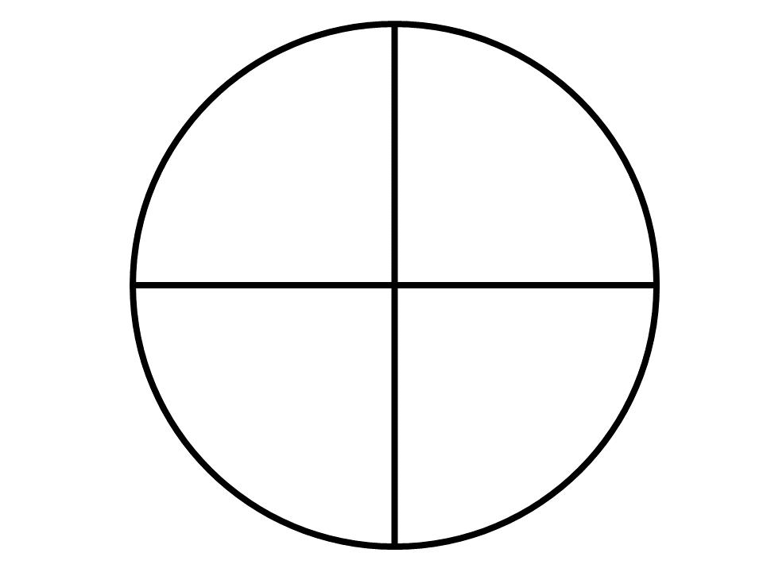

Main Classification
# Source: AI Source: Provided by: [Data Path: Persons Table -> ID Column: 1, Name_En Column: Motasem Essam] -> From: [ChatGPT] on [7/25/2026]
The following is a practical classification of circular dissection methods. These categories are descriptive rather than a universally standardized taxonomy, and some may overlap.

1. Sector-Based Circular Dissection
# Source: AI Source: Provided by: [Data Path: Persons Table -> ID Column: 1, Name_En Column: Motasem Essam] -> From: [ChatGPT] on [7/25/2026]
Divides a disk into sectors using radii and circular arcs.
Example: A disk divided into six equal sectors, each with a central angle of ${60}^{∘}$.
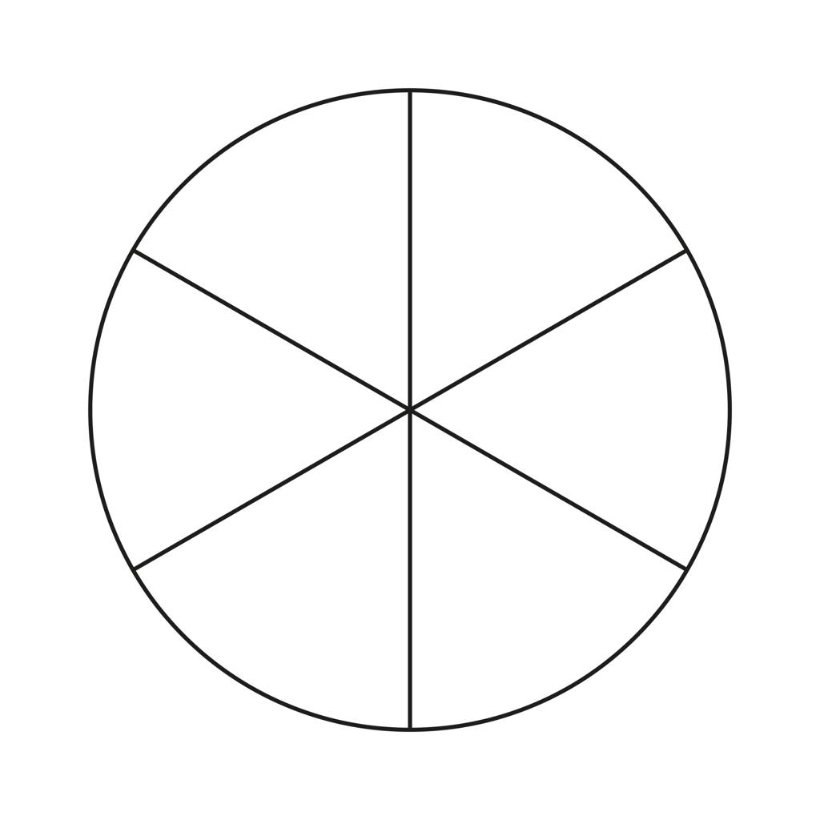
Detailed Explanation of Each Type
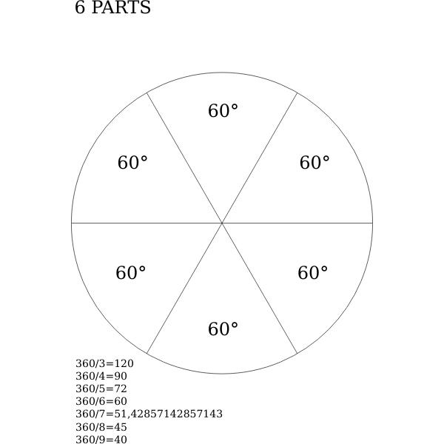
Definition: Dividing a circular disk into sectors by drawing radii from the center to the circumference.
A sector is bounded by two radii and the arc between their endpoints.
Example: A disk of radius $6$ is divided into six equal sectors.
The area of the complete disk is
$$A=πr^{2}=36π$$
Each sector has a central angle of
$$θ=\frac{{360}^{∘}}{6}={60}^{∘}$$
The area of each sector is
$$A_{\text{sector}}=\frac{{60}^{∘}}{{360}^{∘}}\left(36π\right)=\boxed{6π}$$
The six sectors have a combined area of $36π$, equal to the original disk's area.

2. Diameter-Based Circular Dissection
# Source: AI Source: Provided by: [Data Path: Persons Table -> ID Column: 1, Name_En Column: Motasem Essam] -> From: [ChatGPT] on [7/25/2026]
Uses one or more diameters to divide a disk into semicircles or smaller regions.
Example: Two perpendicular diameters create four equal quarter-disks.
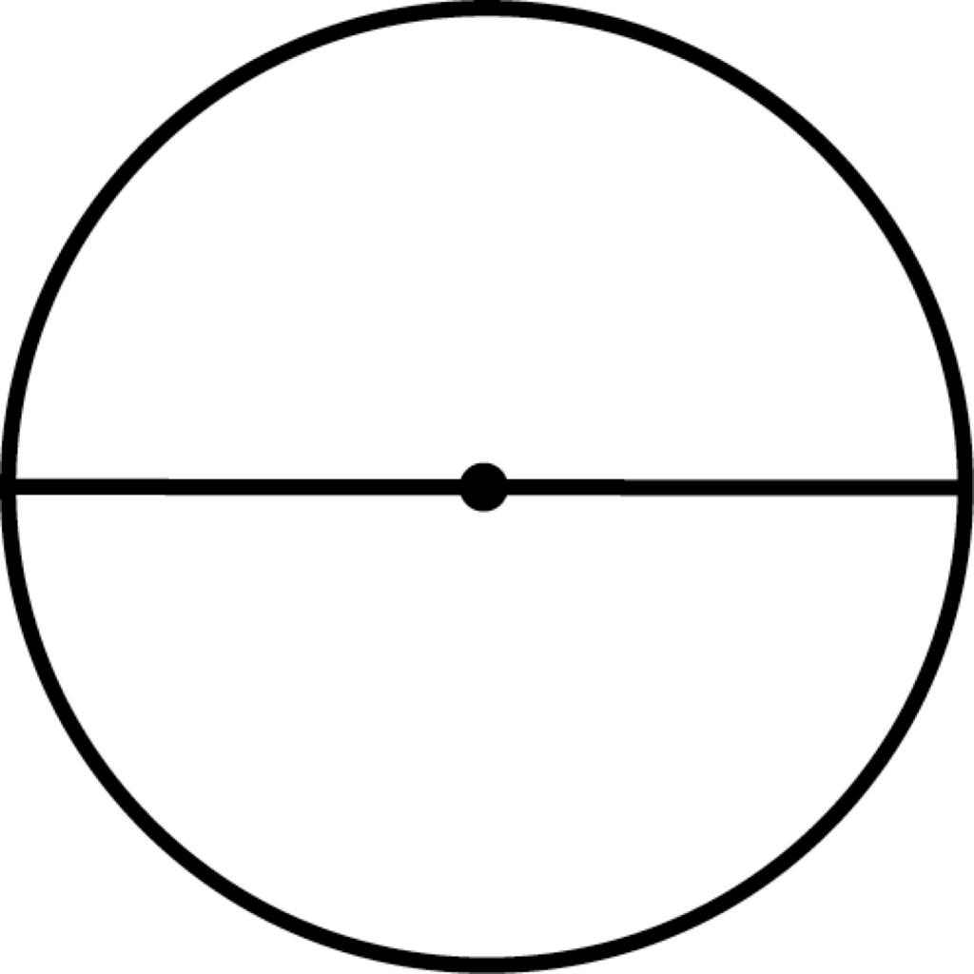
Detailed Explanation of Each Type
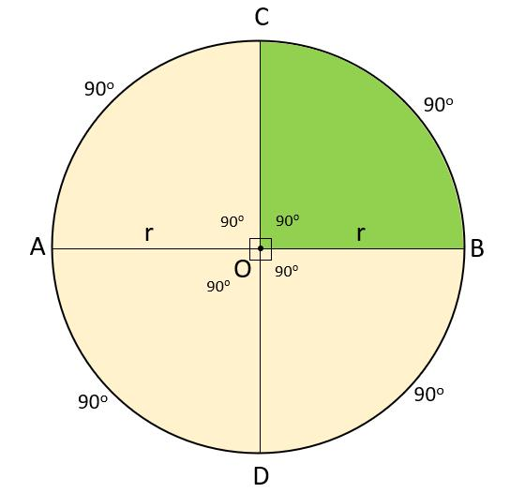
Definition: Dividing a disk by one or more diameters, each of which passes through the center and connects two points on the circumference.
Example: A disk of radius $5$ is divided into four equal regions by two perpendicular diameters.
The original area is
$$A=π{\left(5\right)}^{2}=25π$$
Each quarter-disk has area
$$A_{\text{quarter}}=\frac{25π}{4}$$
Therefore, the four regions have total area
$$4\left(\frac{25π}{4}\right)=\boxed{25π}$$
A single diameter produces two equal semicircles. Two perpendicular diameters produce four equal quarter-disks.

3. Chord-Based Circular Dissection
# Source: AI Source: Provided by: [Data Path: Persons Table -> ID Column: 1, Name_En Column: Motasem Essam] -> From: [ChatGPT] on [7/25/2026]
Uses chords to divide a disk into circular segments or multiple regions.
Example: Two parallel chords create three regions in a disk.
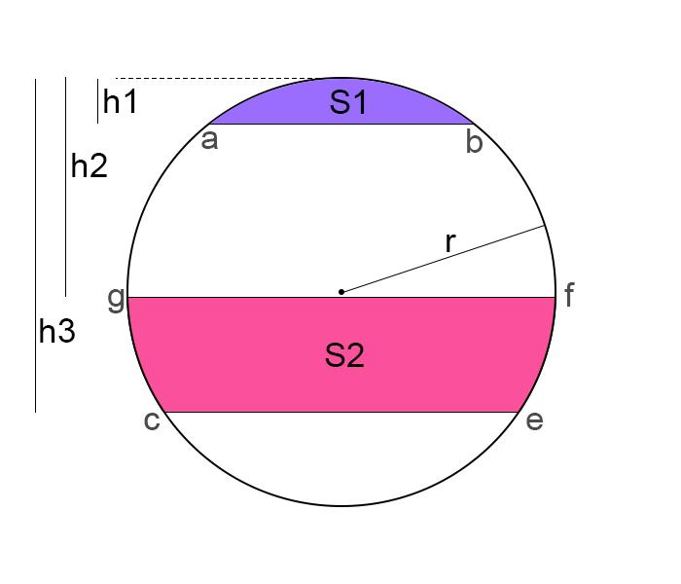
Detailed Explanation of Each Type
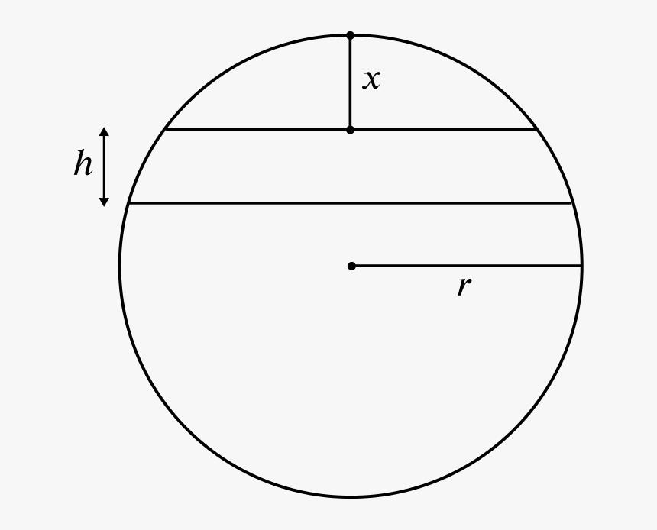
Definition: Dividing a disk using chords—straight segments whose endpoints lie on the circumference.
A chord that does not pass through the center generally divides the disk into two regions: a minor segment and a major segment.
Example: A disk of radius $5$ contains a chord whose perpendicular distance from the center is $3$.
The chord length is
$$c=2\sqrt{r^{2}-d^{2}}$$
where $r=5$ and $d=3$. Therefore,
$$c=2\sqrt{25-9}=\boxed{8}$$
The central angle subtended by the minor arc is
$$θ=2\cos^{-1}\left(\frac{3}{5}\right)$$
in radians, with the angle approximately $1.855$ radians.
The minor-segment area is the sector area minus the isosceles triangle area:
$$A_{\text{segment}}=\frac{1}{2}r^{2}\left(θ-\sin{θ}\right)$$
Substituting $r=5$ gives approximately
$$A_{\text{segment}}≈4.09$$
The major-segment area is $25π-A_{\text{segment}}$, so the two regions together retain the original disk's area.

4. Concentric-Circle Dissection
# Source: AI Source: Provided by: [Data Path: Persons Table -> ID Column: 1, Name_En Column: Motasem Essam] -> From: [ChatGPT] on [7/25/2026]
Uses circles sharing the same center to create a central disk and surrounding rings.
Example: A disk divided by a smaller concentric circle into an inner disk and an annulus.
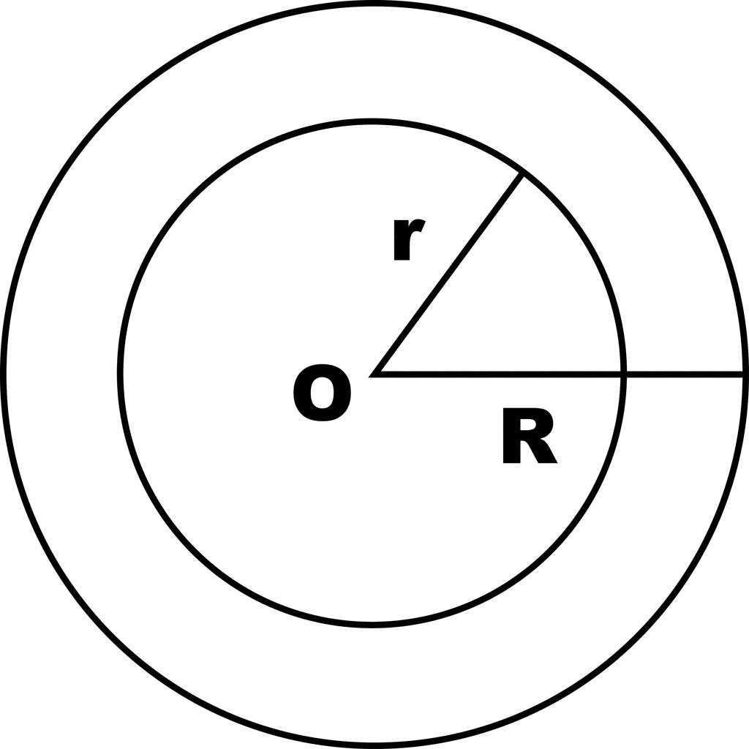
Detailed Explanation of Each Type
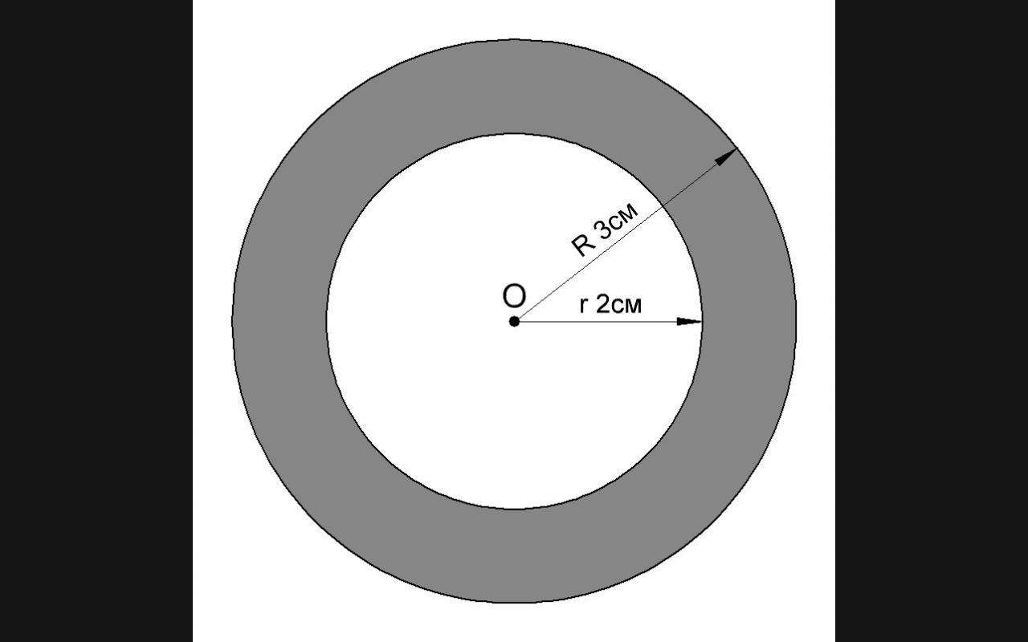
Definition: Dividing a disk or circular region using circles that share the same center.
The result may include a central disk and one or more surrounding annuli.
Example: Two concentric circles have radii $6$ and $3$.
The outer disk has area
$$A_{\text{outer}}=36π$$
The inner disk has area
$$A_{\text{inner}}=9π$$
The annulus between them has area
$$A_{\text{annulus}}=π\left(6^{2}-3^{2}\right)=\boxed{27π}$$
The central disk and annulus together have area $9π+27π=36π$.

5. Annular Dissection
# Source: AI Source: Provided by: [Data Path: Persons Table -> ID Column: 1, Name_En Column: Motasem Essam] -> From: [ChatGPT] on [7/25/2026]
Divides the ring-shaped region between two concentric circles into smaller regions.
Example: An annulus divided into four equal quarter-annuli.
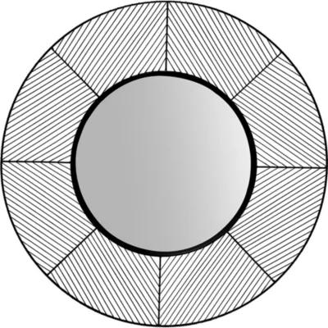
Detailed Explanation of Each Type
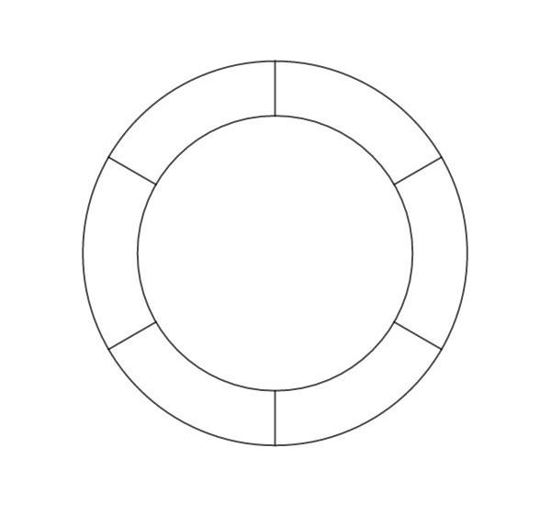
Definition: Dividing an annulus—the region between two concentric circles—into smaller pieces, often using radial segments.
Example: An annulus has outer radius $6$ and inner radius $4$. Two perpendicular radial lines divide it into four equal quarter-annuli.
The complete annulus has area
$$A=π\left(6^{2}-4^{2}\right)=20π$$
Each quarter-annulus has area
$$A_{\text{piece}}=\frac{20π}{4}=\boxed{5π}$$
The four pieces reconstruct the full annulus.

6. Unequal-Sector Circular Dissection
# Source: AI Source: Provided by: [Data Path: Persons Table -> ID Column: 1, Name_En Column: Motasem Essam] -> From: [ChatGPT] on [7/25/2026]
Divides a disk into sectors with different central angles.
Example: A disk divided into sectors of ${60}^{∘}$, ${120}^{∘}$, and ${180}^{∘}$.
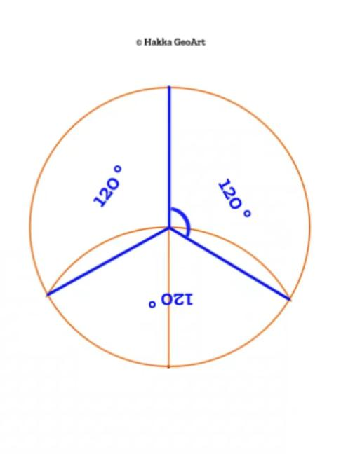
Detailed Explanation of Each Type
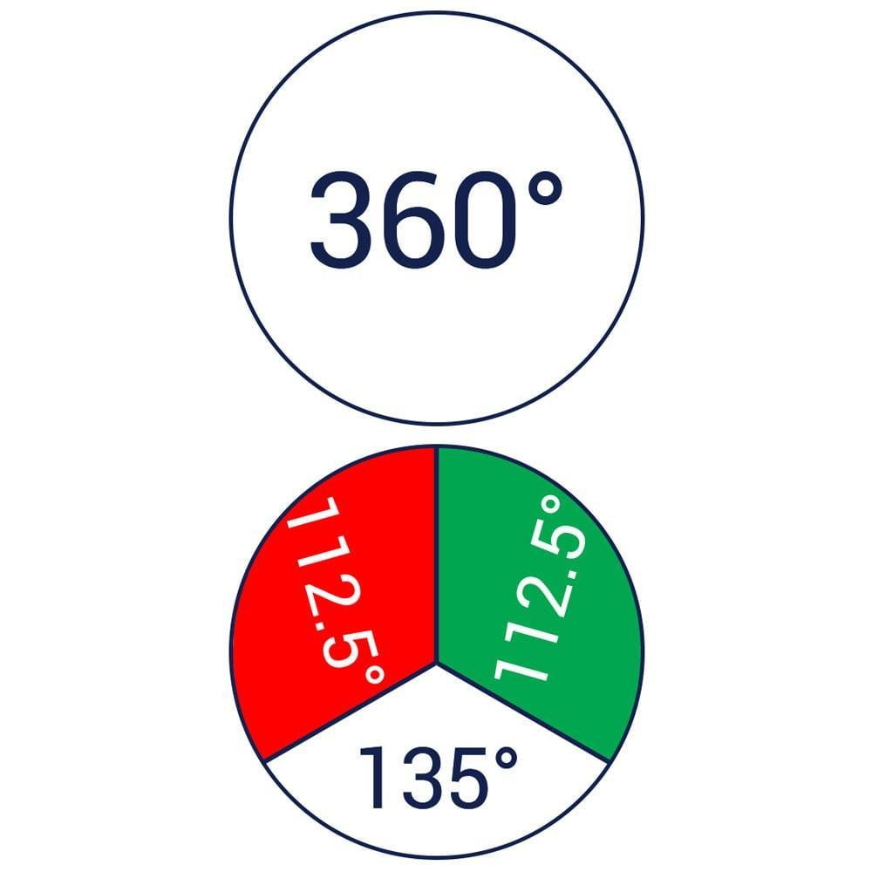
Definition: Dividing a disk into sectors with different central angles.
Example: A disk of radius $6$ is divided into three sectors with angles ${60}^{∘}$, ${120}^{∘}$, and ${180}^{∘}$.
The angles sum to
$${60}^{∘}+{120}^{∘}+{180}^{∘}={360}^{∘}$$
Their respective areas are
$$A_{1}=\frac{60}{360}\left(36π\right)=6π$$
$$A_{2}=\frac{120}{360}\left(36π\right)=12π$$
$$A_{3}=\frac{180}{360}\left(36π\right)=18π$$
Thus,
$$A_{1}+A_{2}+A_{3}=\boxed{36π}$$
The area of a sector is proportional to its central angle when all sectors have the same radius.

7. Multiple-Chord Circular Dissection
# Source: AI Source: Provided by: [Data Path: Persons Table -> ID Column: 1, Name_En Column: Motasem Essam] -> From: [ChatGPT] on [7/25/2026]
Uses several chords to create multiple regions within a disk.
Example: Three chords in general position intersect to divide a disk into several regions.
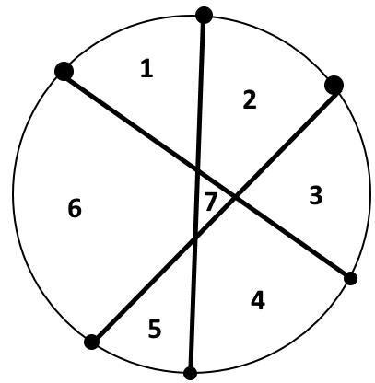
Detailed Explanation of Each Type
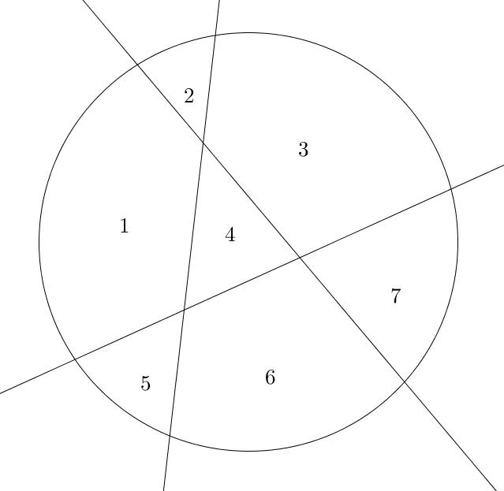
Definition: Using multiple chords to create several regions inside a disk.
Example: Three chords intersect pairwise at three distinct interior points, with no three chords meeting at one interior point. Each new chord is divided into two parts by the previous chords, so it creates two additional regions.
Starting with one region:
- First chord: $2$ regions.
- Second chord: $4$ regions.
- Third chord: $7$ regions.
Therefore, three chords in this arrangement create
$$\boxed{7\text{ regions}}$$
More generally, if $n$ chords are in general position—no parallel pair and no triple intersection in the disk—the maximum number of regions is
$$R=1+n+\frac{n\left(n-1\right)}{2}$$
The formula assumes each pair of chords intersects inside the disk at a distinct point.

8. Mixed Circular–Polygonal Dissection
# Source: AI Source: Provided by: [Data Path: Persons Table -> ID Column: 1, Name_En Column: Motasem Essam] -> From: [ChatGPT] on [7/25/2026]
Divides a figure containing circular and polygonal boundaries into simpler regions.
Example: A rectangle with a semicircular end, separated into a rectangle and a semicircle.
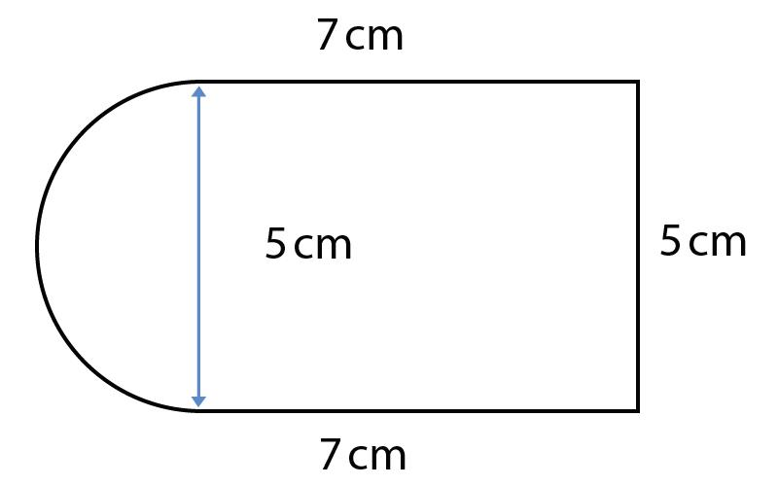
Detailed Explanation of Each Type
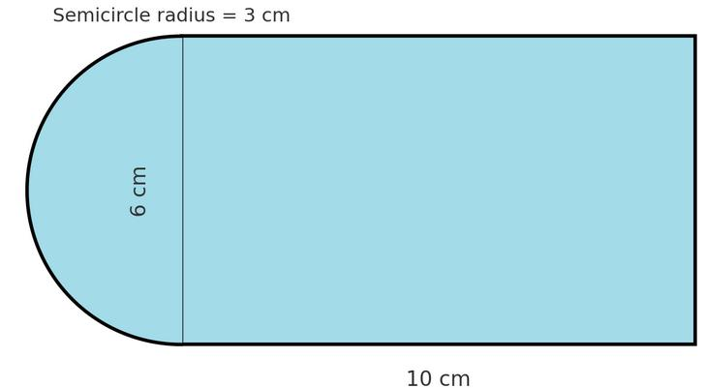
Definition: Dividing a figure that combines circular and polygonal boundaries into simpler regions.
Example: A rectangle of dimensions $8×6$ has a semicircle of radius $3$ attached to one of its shorter sides.
The rectangle's area is
$$A_{\text{rectangle}}=8\left(6\right)=48$$
The semicircle's area is
$$A_{\text{semicircle}}=\frac{1}{2}π{\left(3\right)}^{2}=\frac{9π}{2}$$
The composite figure's area is
$$A=48+\frac{9π}{2}≈\boxed{62.14}$$
This method is useful for calculating the area of composite figures such as windows, signs, architectural designs, and other shapes with straight and curved boundaries.

9. Overlapping-Circle Dissection
# Source: AI Source: Provided by: [Data Path: Persons Table -> ID Column: 1, Name_En Column: Motasem Essam] -> From: [ChatGPT] on [7/25/2026]
Analyzes the regions formed by intersecting circular boundaries.
Example: Two overlapping disks form a lens-shaped intersection and non-overlapping portions.
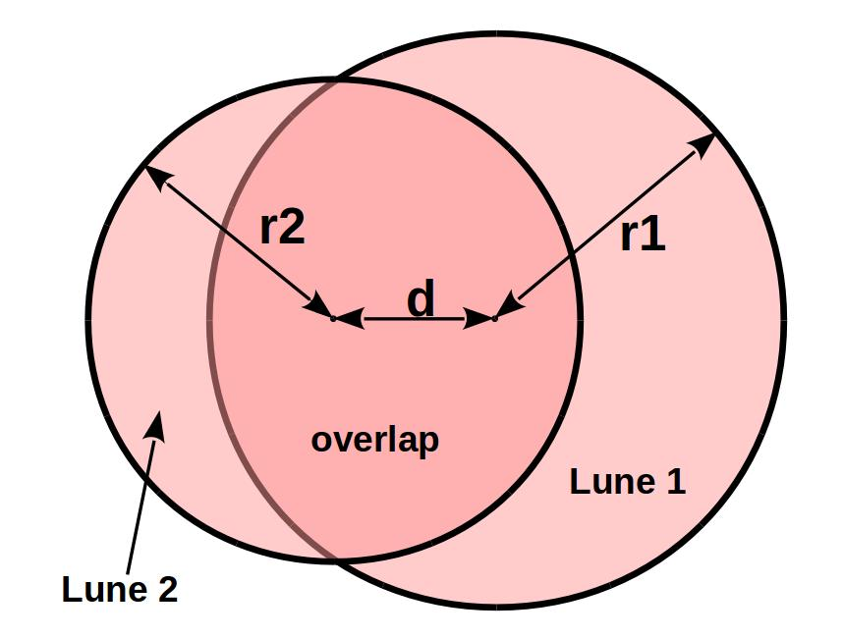
Detailed Explanation of Each Type
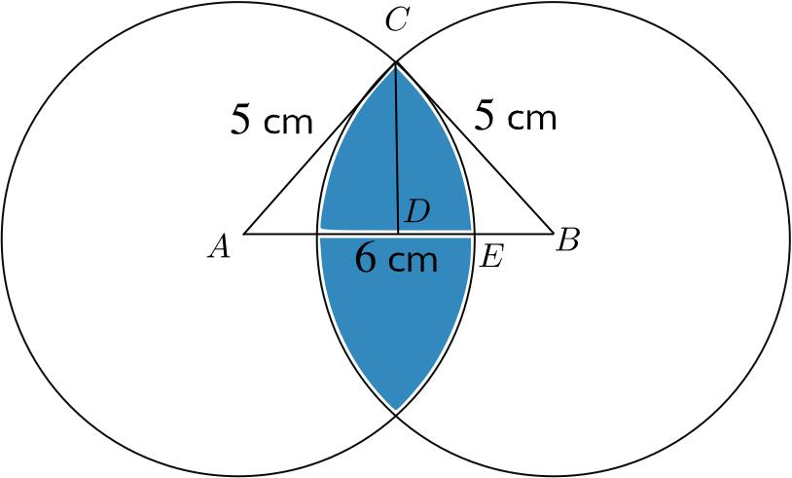
Definition: Analyzing the regions created when two or more circular disks overlap.
Unlike a disjoint dissection, overlapping-circle analysis must account for the shared region so that it is not counted twice.
Example: Two circles each have radius $5$, and the distance between their centers is $6$.
The intersection is a lens-shaped region. For two equal circles of radius $r$, with center distance $d$, the lens area is
$$A_{\text{lens}}=2r^{2}\cos^{-1}\left(\frac{d}{2r}\right)-\frac{d}{2}\sqrt{4r^{2}-d^{2}}$$
Substituting $r=5$ and $d=6$:
$$A_{\text{lens}}=50\cos^{-1}\left(\frac{3}{5}\right)-24\sqrt{1}$$Hence,
$$A_{\text{lens}}=50\cos^{-1}\left(\frac{3}{5}\right)-24≈\boxed{22.36}$$
The intersection area is counted only once. For the union of two disks,
$$A_{A∪B}=A_{A}+A_{B}-A_{A∩B}$$

10. Combined Circular Dissection
# Source: AI Source: Provided by: [Data Path: Persons Table -> ID Column: 1, Name_En Column: Motasem Essam] -> From: [ChatGPT] on [7/25/2026]
Combines two or more cutting methods in the same figure.
Example: Concentric circles and perpendicular diameters create a central disk and four annular sectors.
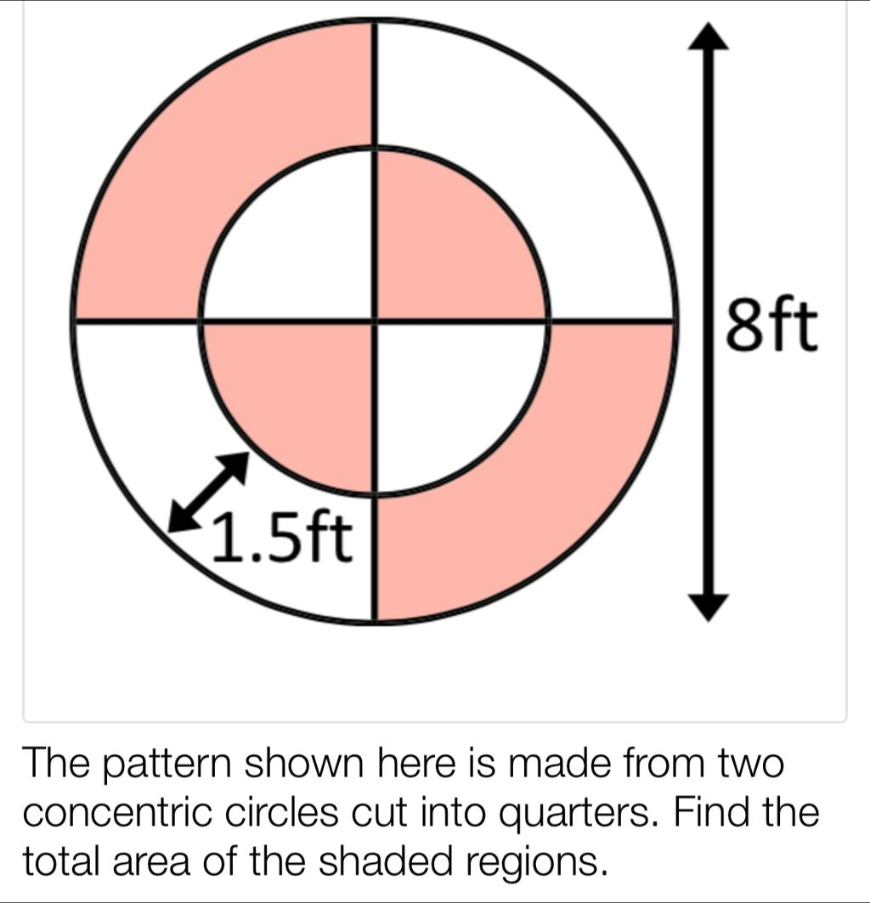
Detailed Explanation of Each Type
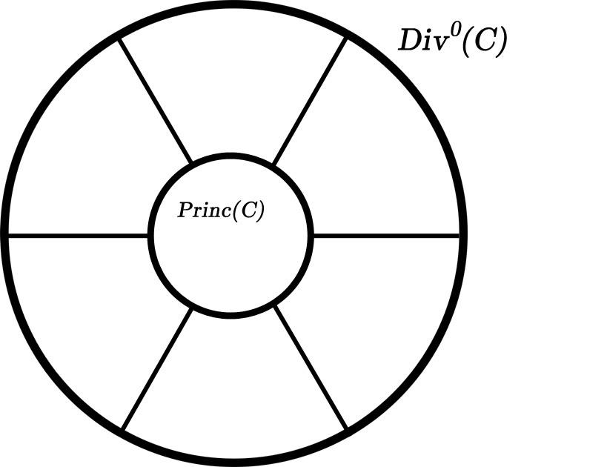
Definition: Combining multiple circular dissection methods in the same figure.
Example: A disk of radius $6$ contains a concentric circle of radius $3$, and two perpendicular diameters divide both the inner disk and the surrounding annulus into quarters.
The central disk has area
$$A_{\text{inner}}=9π$$
Each quarter of the central disk has area
$$A_{\text{inner quarter}}=\frac{9π}{4}$$
The annulus has area
$$A_{\text{annulus}}=36π-9π=27π$$
Each quarter-annulus has area
$$A_{\text{annular quarter}}=\frac{27π}{4}$$
Adding the four central quarters and four annular quarters gives
$$4\left(\frac{9π}{4}\right)+4\left(\frac{27π}{4}\right)=\boxed{36π}$$
This example combines concentric-circle, diameter-based, and annular dissection.
Correction to Example 4.3: The minor-segment area for $r=5$ and $d=3$ is approximately $11.18$, not $4.09$. The correct calculation is
$$\begin{aligned}A_{\text{segment}}&=\frac{1}{2}\left(25\right)\left(1.85459-0.96\right) \\ &≈\boxed{11.18}\end{aligned}$$

Key Formulas for Circular Dissection
# Source: AI Source: Provided by: [Data Path: Persons Table -> ID Column: 1, Name_En Column: Motasem Essam] -> From: [ChatGPT] on [7/25/2026]
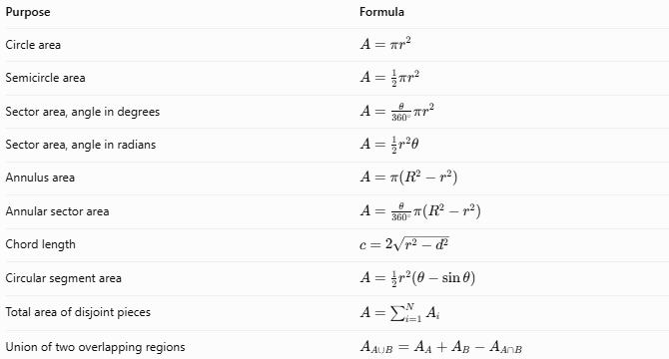
Purpose | Formula
Circle area | $$A=πr^{2}$$
Semicircle area | $$A=\frac{1}{2}πr^{2}$$
Sector area, angle in degrees | $$A=\frac{θ}{{360}^{∘}}πr^{2}$$
Sector area, angle in radians | $$A={\frac{1}{2}r}^{2}θ$$
Annulus area | $$A=π\left(R^{2}-r^{2}\right)$$
Annular sector area | $$A=\frac{θ}{{360}^{∘}}π\left(R^{2}-r^{2}\right)$$
Chord length | $$c=2\sqrt{r^{2}-d^{2}}$$
Circular segment area | $$A={\frac{1}{2}r}^{2}\left(θ-\sin{θ}\right)$$
Total area of disjoint pieces | $$A=\sum_{i=1}^{N}{A_{i}}$$
Union of two overlapping regions | $$A_{A∪B}=A_{A}+A_{B}-A_{A∩B}$$
Here, $r$ is the inner radius or radius of the disk, $R$ is the outer radius of an annulus, $d$ is the perpendicular distance from the center to a chord, and $θ$ is the central angle in the appropriate units.
For the circular-segment formula, $θ$ must be in radians, and the formula shown gives the minor segment for a central angle between $0$ and $π$.

Comparison with Other Dissection Methods
# Source: AI Source: Provided by: [Data Path: Persons Table -> ID Column: 1, Name_En Column: Motasem Essam] -> From: [ChatGPT] on [7/25/2026]
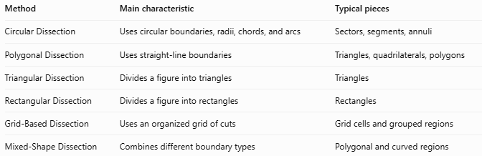
Method | Main characteristic | Typical pieces
Circular Dissection | Uses circular boundaries, radii, chords, and arcs | Sectors, segments, annuli
Polygonal Dissection | Uses straight-line boundaries | Triangles, quadrilaterals, polygons
Triangular Dissection | Divides a figure into triangles | Triangles
Rectangular Dissection | Divides a figure into rectangles | Rectangles
Grid-Based Dissection | Uses an organized grid of cuts | Grid cells and grouped regions
Mixed-Shape Dissection | Combines different boundary types | Polygonal and curved regions
Important distinction: Circular dissection can produce curved-boundary pieces, whereas polygonal dissection produces pieces bounded by straight segments. Mixed-shape dissection may combine both methods in a single figure.

Classification Summary
# Source: AI Source: Provided by: [Data Path: Persons Table -> ID Column: 1, Name_En Column: Motasem Essam] -> From: [ChatGPT] on [7/25/2026]
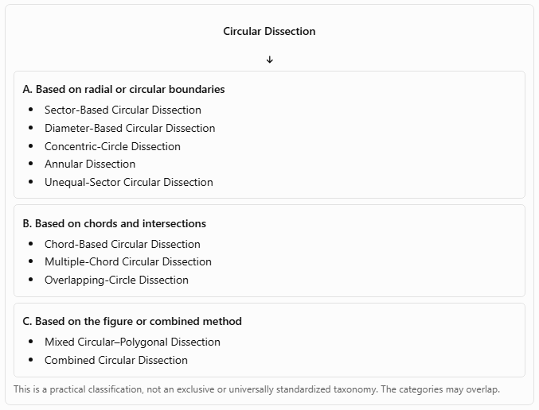
Circular Dissection
A. Based on radial or circular boundaries
- Sector-Based Circular Dissection
- Diameter-Based Circular Dissection
- Concentric-Circle Dissection
- Annular Dissection
- Unequal-Sector Circular Dissection
B. Based on chords and intersections
- Chord-Based Circular Dissection
- Multiple-Chord Circular Dissection
- Overlapping-Circle Dissection
C. Based on the figure or combined method
- Mixed Circular–Polygonal Dissection
- Combined Circular Dissection
This is a practical classification, not an exclusive or universally standardized taxonomy. The categories may overlap.

Key Points
# Source: AI Source: Provided by: [Data Path: Persons Table -> ID Column: 1, Name_En Column: Motasem Essam] -> From: [ChatGPT] on [7/25/2026]
- Circular dissection divides a disk or circular-containing figure into smaller regions.
- Radii and diameters create sectors and semicircles; chords create circular segments.
- Concentric circles create annuli, which can be subdivided into annular sectors.
- The sum of the areas of disjoint pieces equals the area of the original figure.
- For overlapping disks, subtract the intersection area when calculating their union.
- Central angles must use consistent units in sector and segment formulas.
- Circular dissection is useful in geometry proofs, area calculations, design, and rearrangement problems.

Conclusion
# Source: AI Source: Provided by: [Data Path: Persons Table -> ID Column: 1, Name_En Column: Motasem Essam] -> From: [ChatGPT] on [7/25/2026]
Circular Dissection is a geometric method for partitioning circular figures using radii, diameters, chords, and circular boundaries. It includes sector-based, chord-based, concentric-circle, annular, overlapping-circle, and mixed circular–polygonal approaches.
Its central principle is that the areas of disjoint pieces add up to the original region's area. When pieces overlap, the shared area must be handled carefully to avoid double counting.

